**Assignment 2: Axure Prototyping**

**Name: Ida Bagus Ketut Yoghantara**

Project Scenario

You have been approached by XYZ Tuitions. As part of their new initiative, you are asked to create a Prototype.

1. The tuition center has many teachers and many students. Teachers publish learning materials in a secured area.
2. Each student belong to one class and each teacher belong to multiple class
3. The system should allow teachers to login and publish training materials. Student will be able to login and view the training materials.
4. Create a prototype for the home page, login page, login success page for both students and teachers. Teacher content posting page. Student content viewing page. Student registration page, forgot password and forgot password thank you page.
5. Create the prototype in Axure and provide screen capture

Project Screenshot

**Homepage**

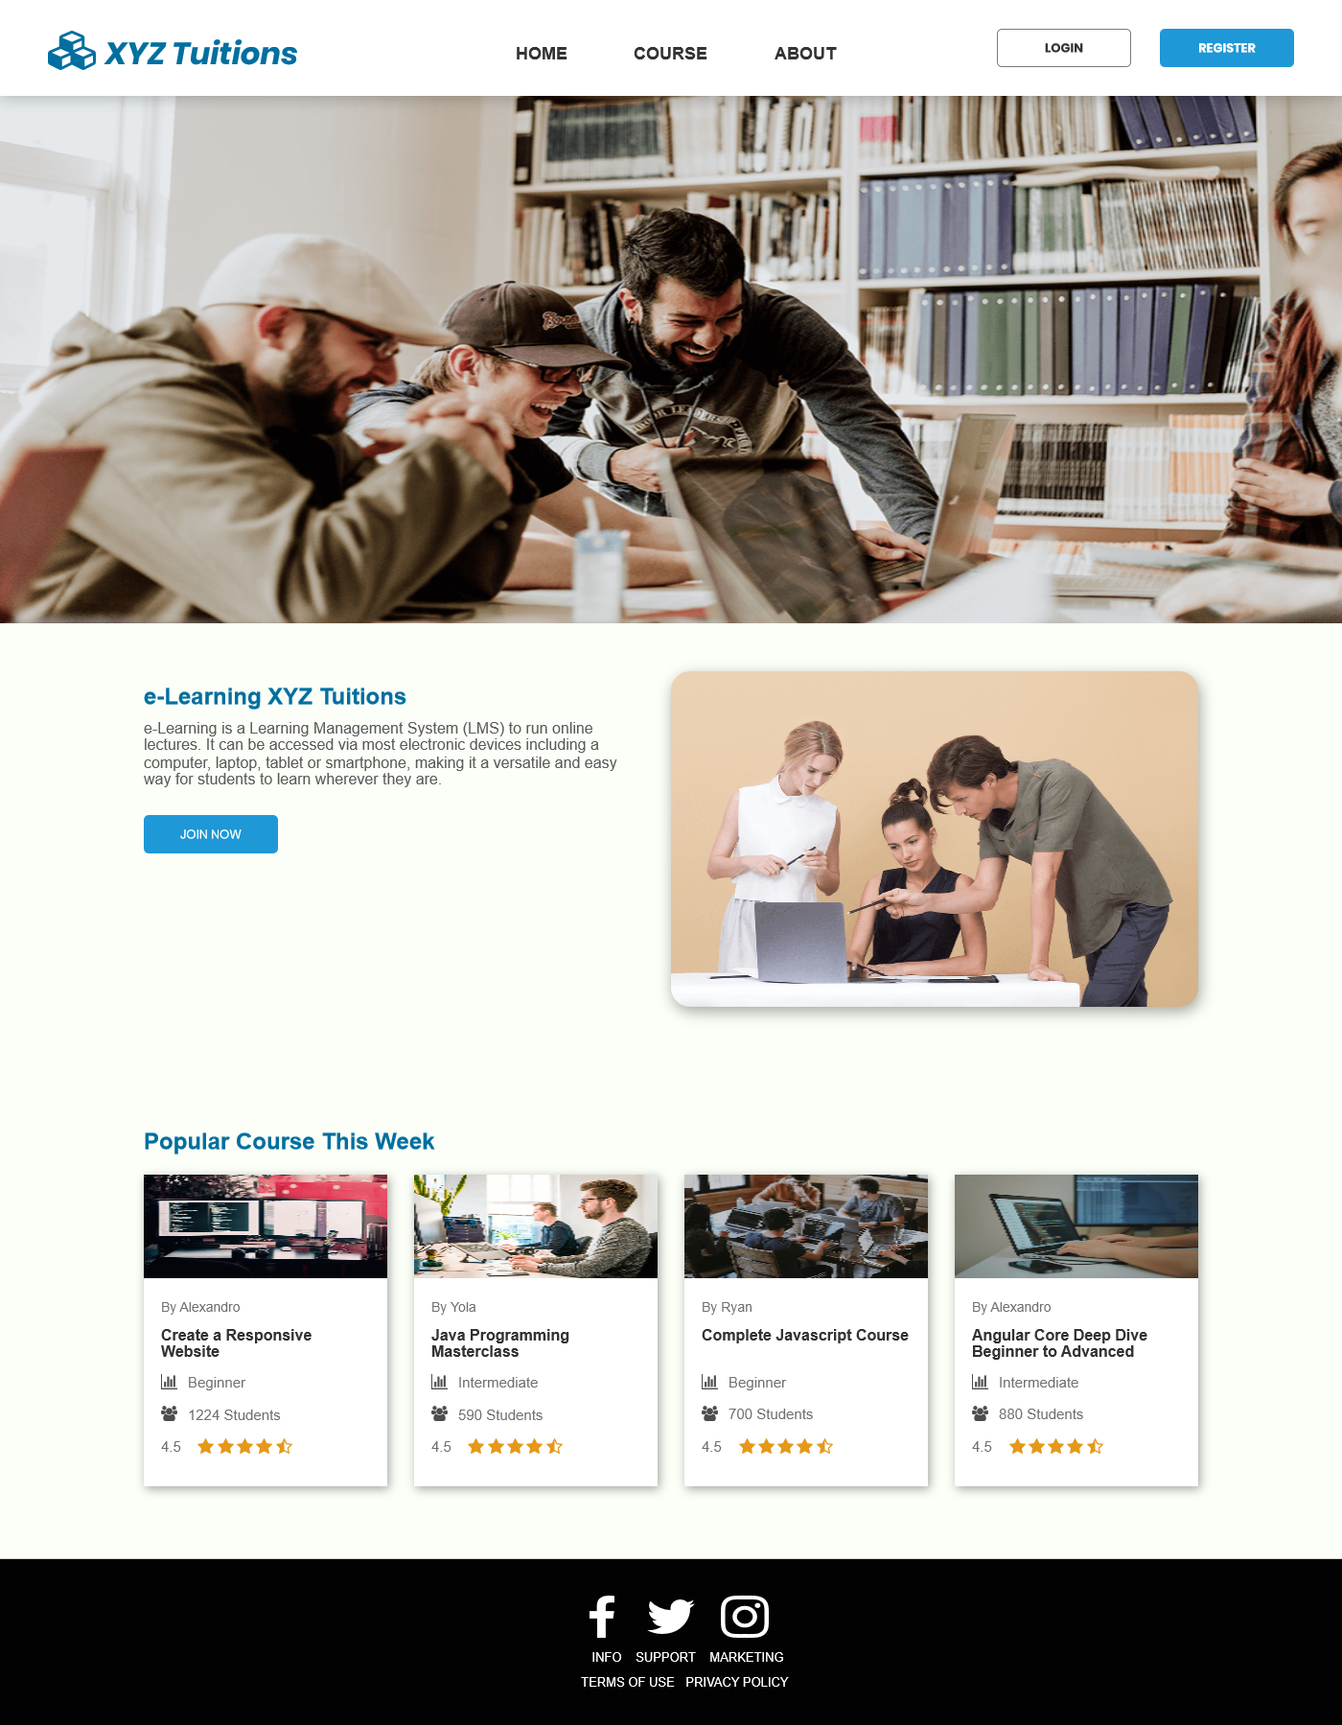

**Login Page**

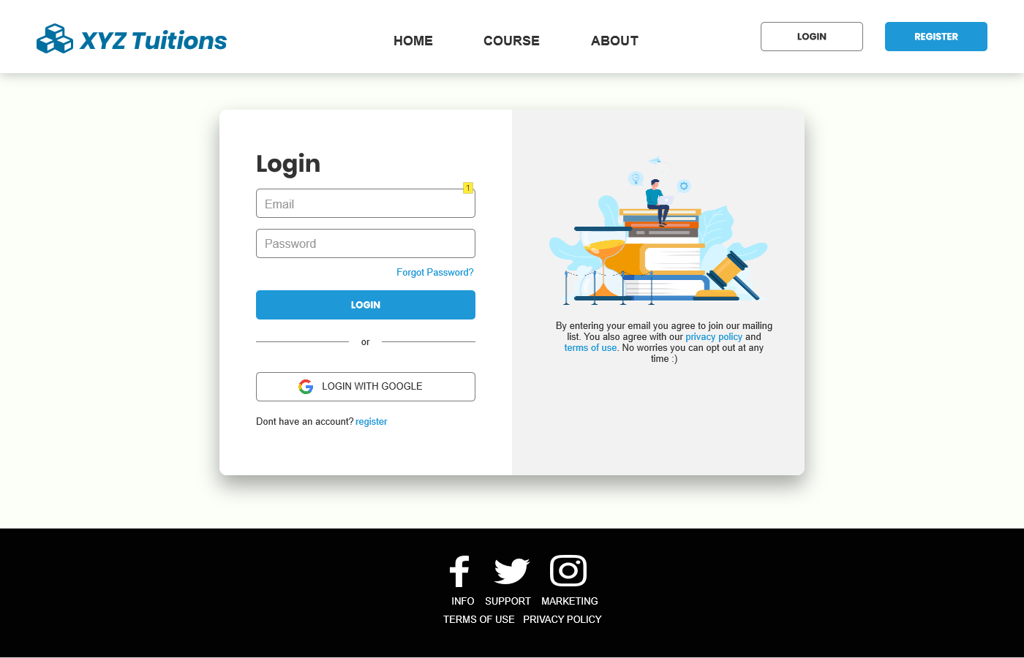

**Student Login Success Page**

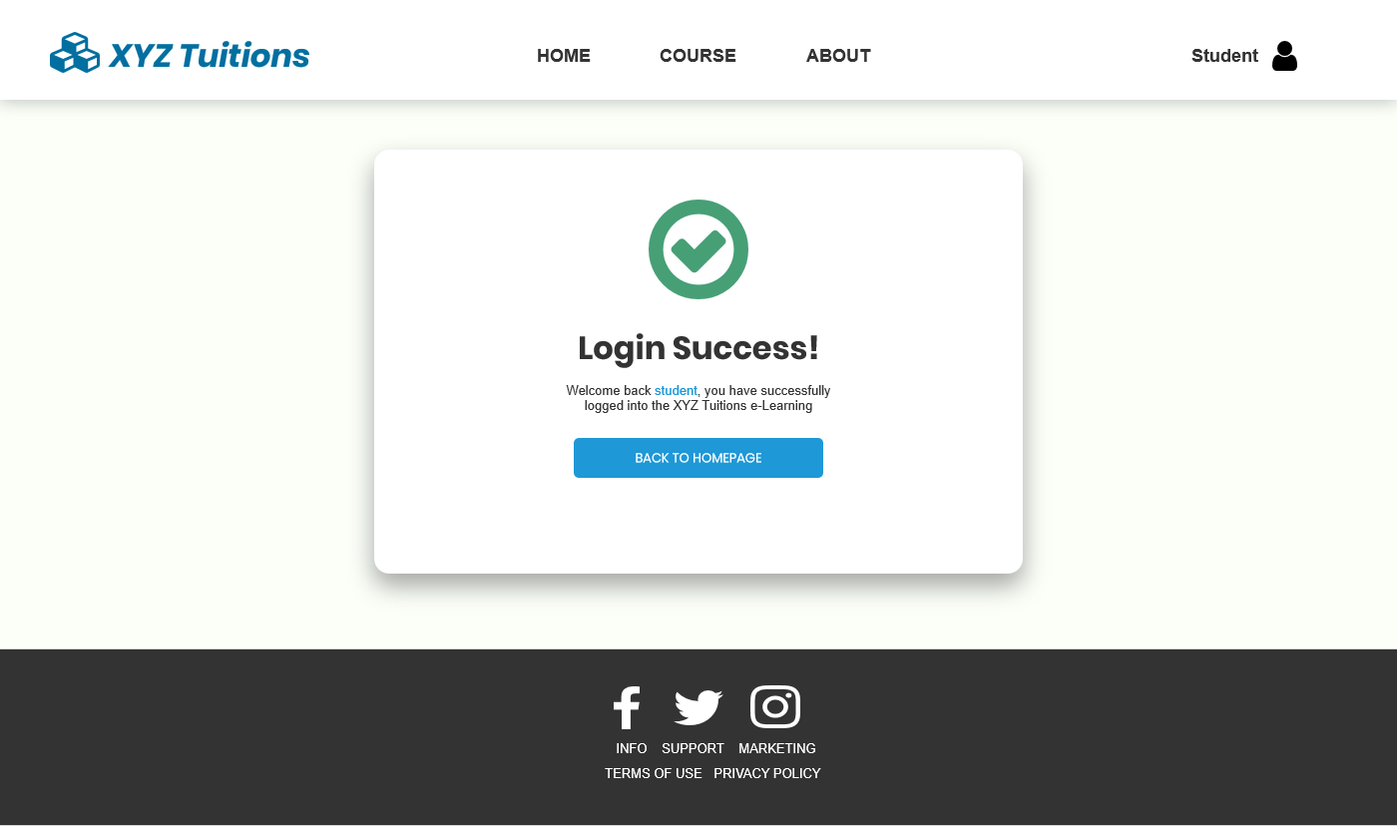

**Teacher Login Success Page**

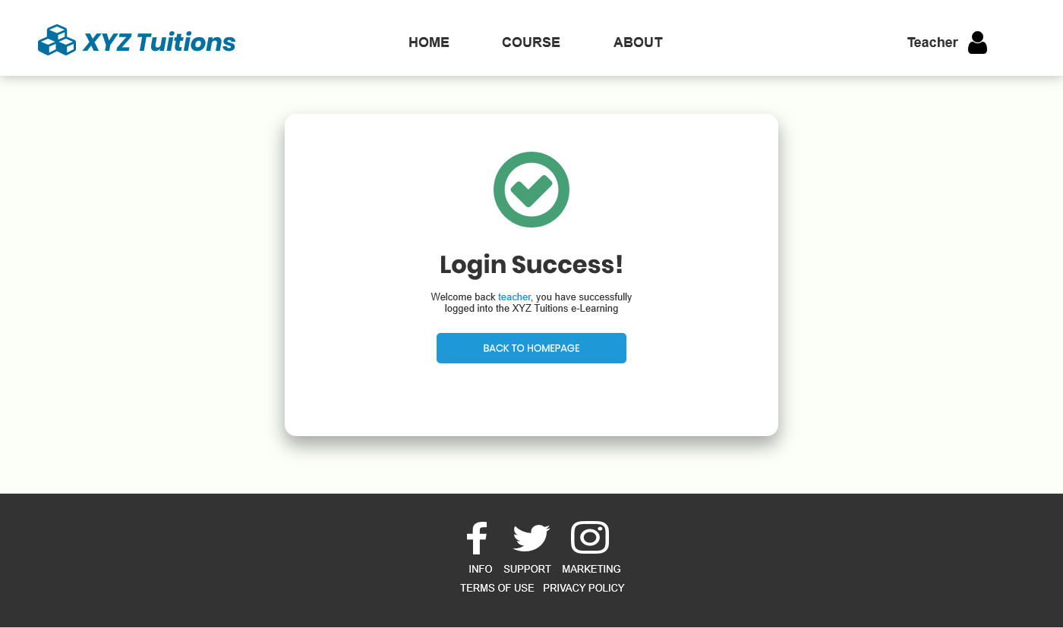

**Student Homepage**

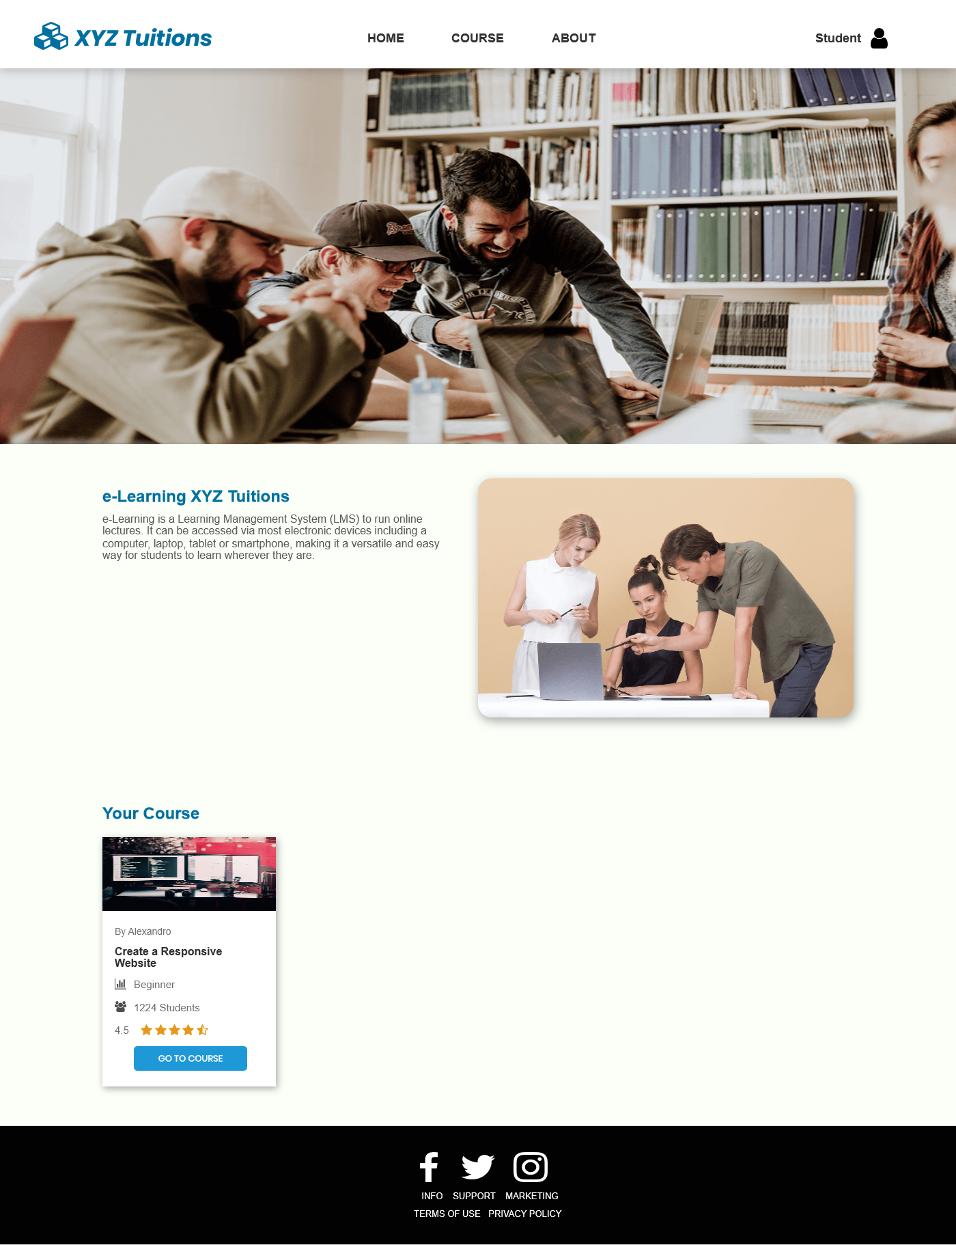

**Teacher Homepage**

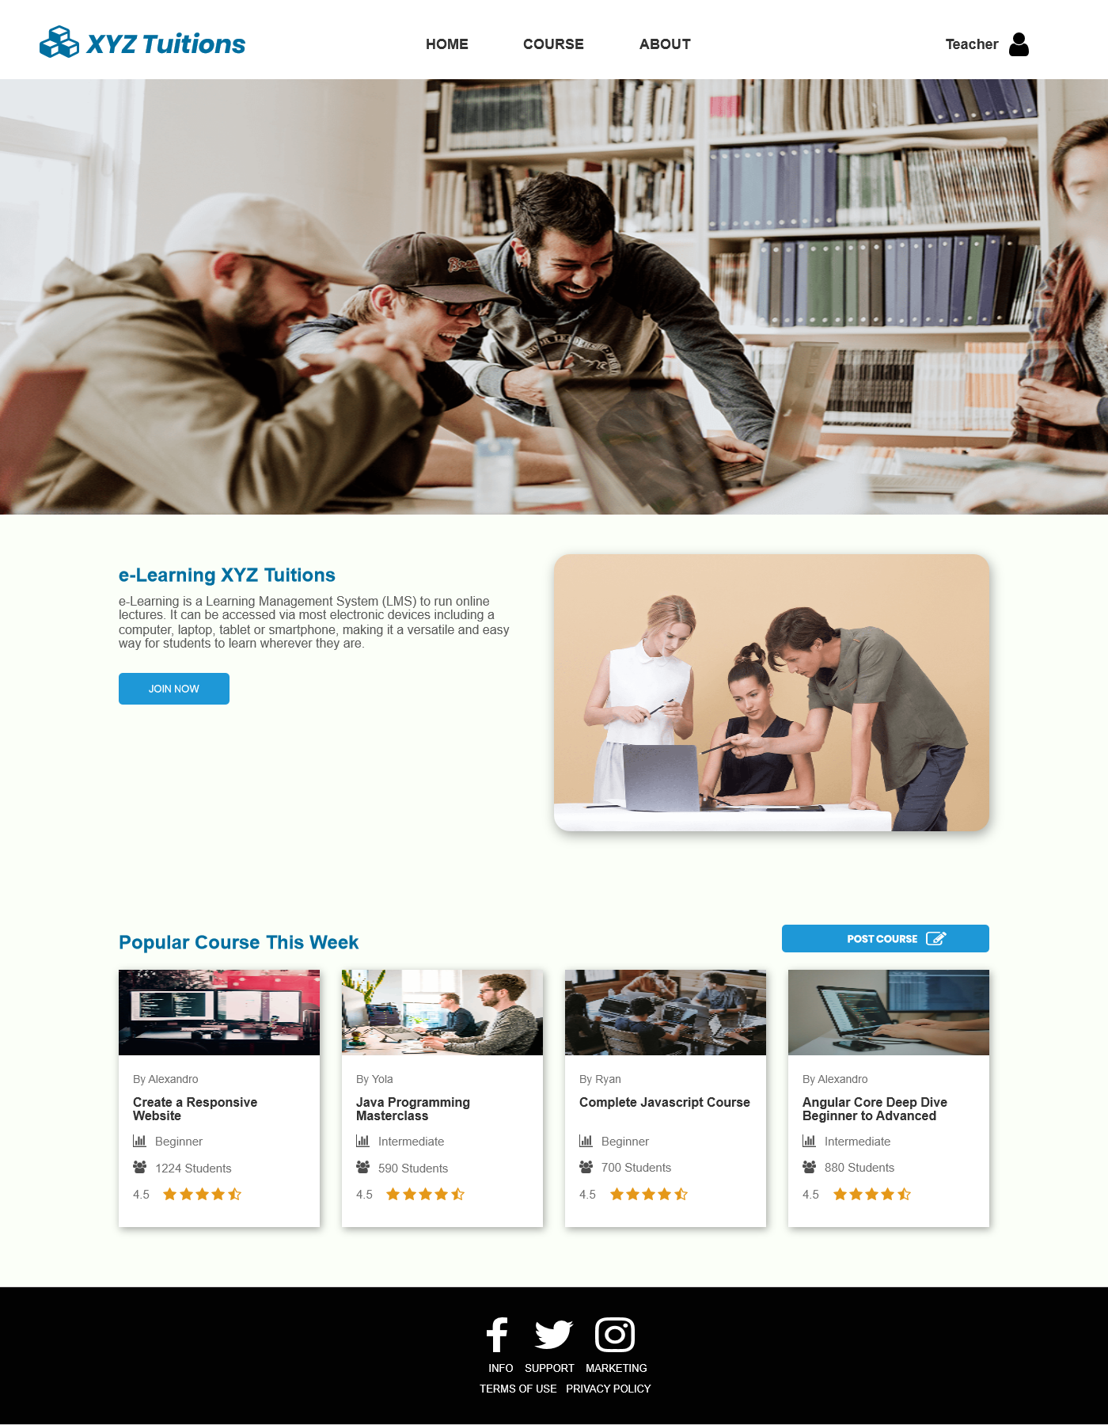

**Register Page**

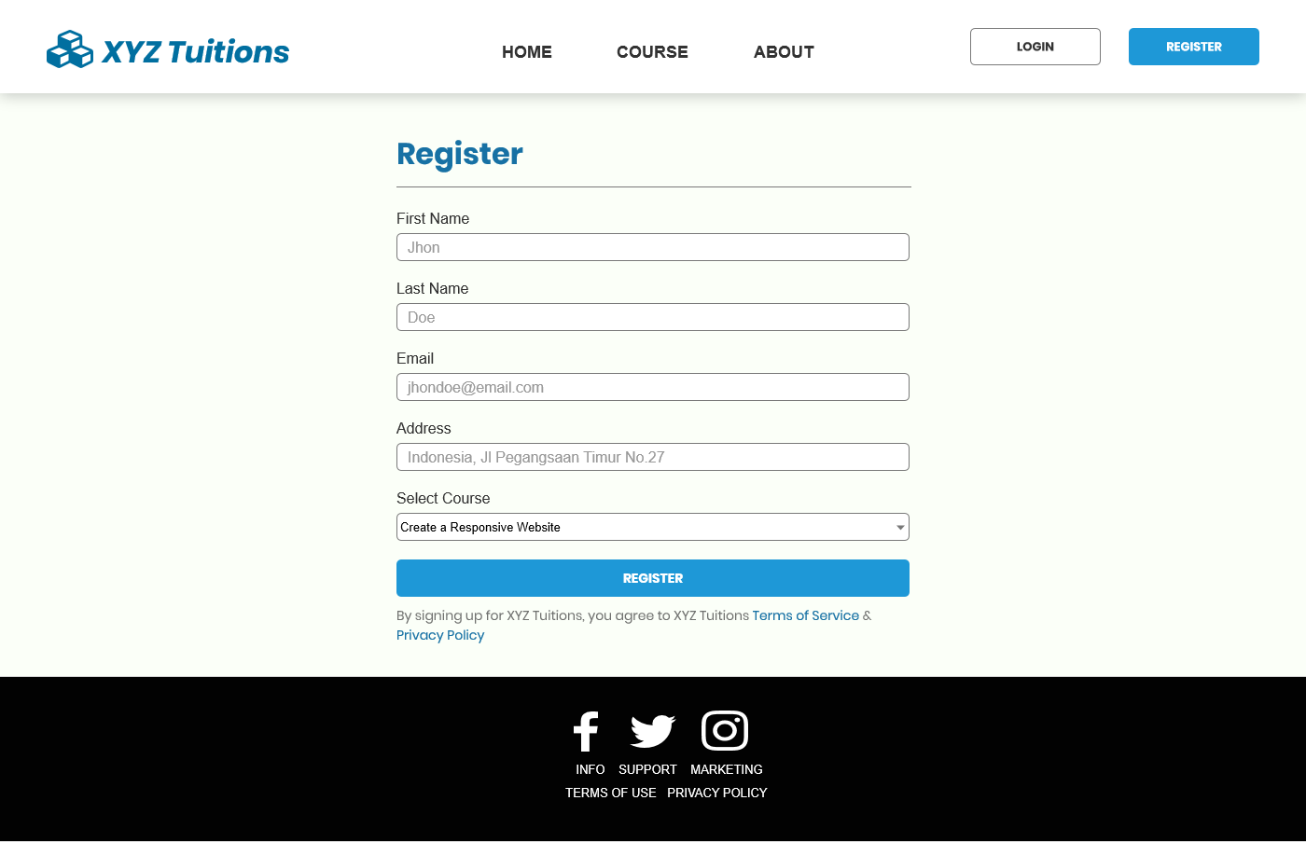

**Forgot Password Page**

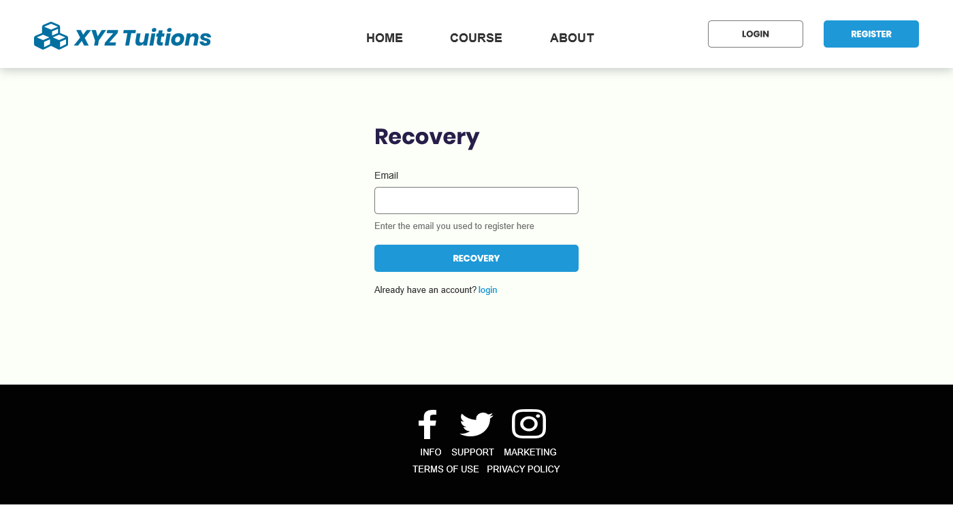

**Forgot Password Thank You Page**

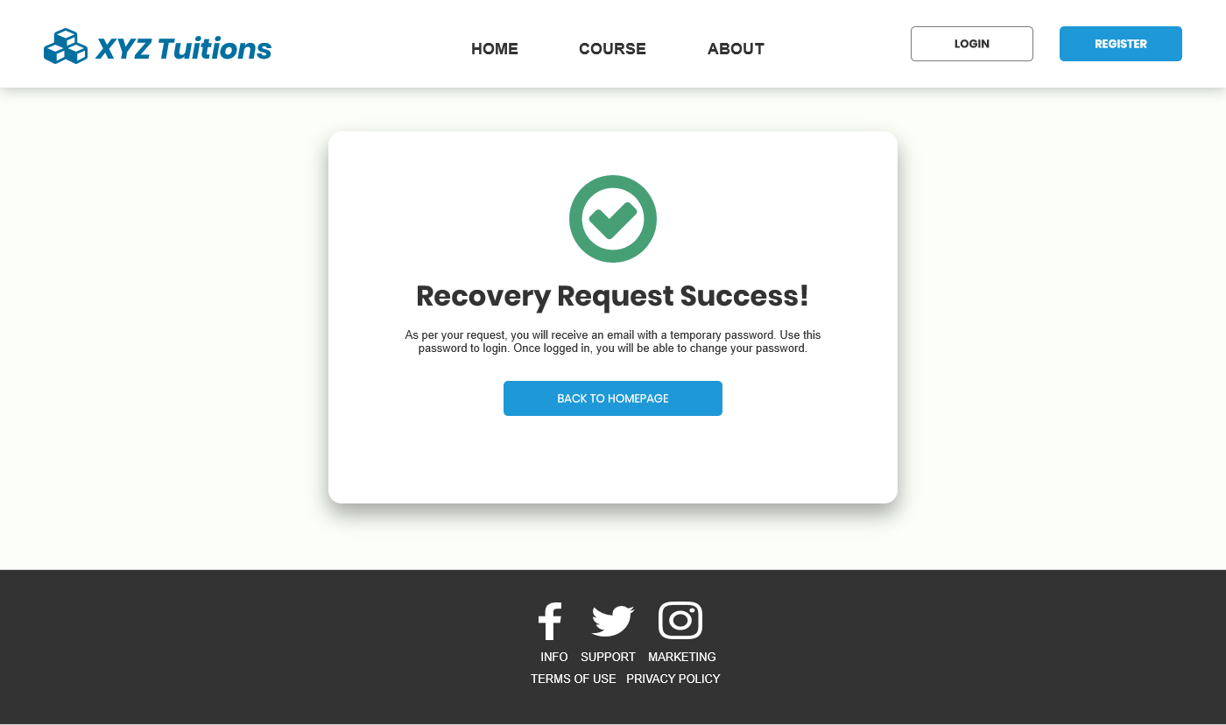

**Teacher Content Posting Page**

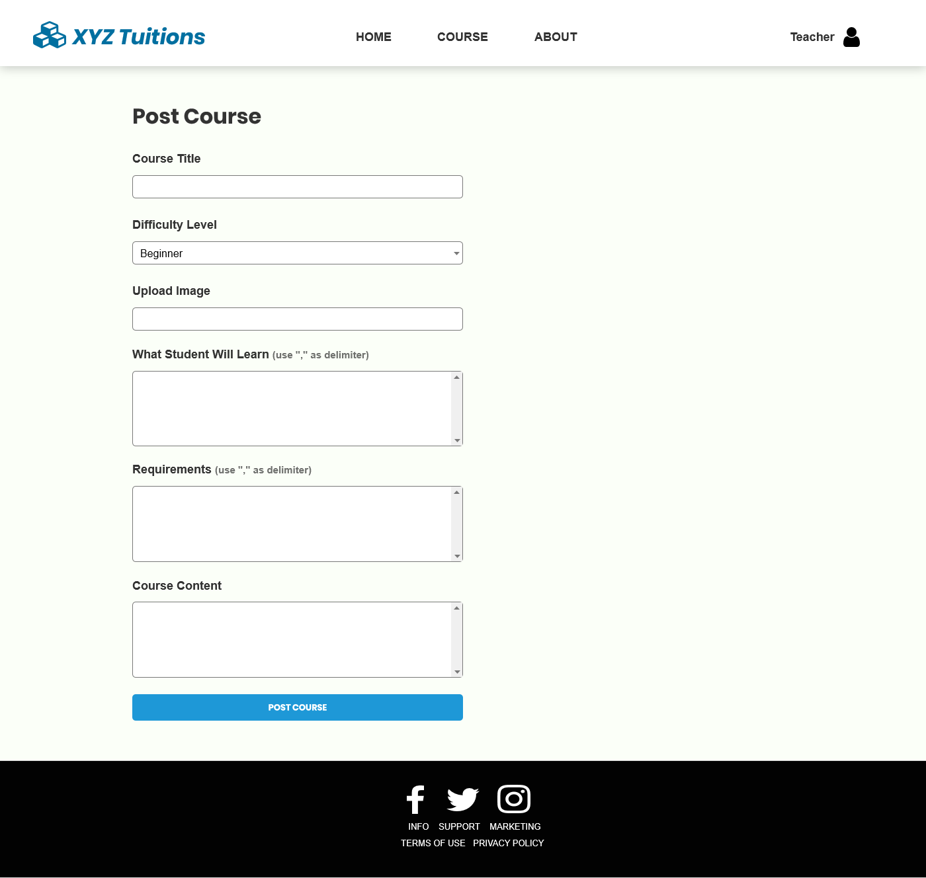

**Student Content Viewing Page**

